**Practical Question -13**

13a –

/** Main.java **/

import java.awt.*;

import java.awt.event.*;

import javax.swing.*;

public class Main {

JLabel l;

Main() {

JFrame f = new JFrame("Swing Frame");

l = new JLabel("", SwingConstants.CENTER);

l.setBounds(15, 110, 260, 30);

f.add(l);

f.addMouseListener(new MouseAdapter() {

@Override

public void mouseClicked(MouseEvent e) {

l.setText("Mouse Clicked");

}

@Override

public void mouseEntered(MouseEvent e) {

l.setText("Mouse Entered");

}

@Override

public void mouseExited(MouseEvent e) {

l.setText("Mouse Exited");

}

});

f.setSize(300, 300);

f.setLayout(null);

f.setVisible(true);

f.setDefaultCloseOperation(JFrame.EXIT_ON_CLOSE);

}

public static void main(String[] args) {

SwingUtilities.invokeLater(new Runnable() {

public void run() {

new Main();

}

});

}

}

Output -

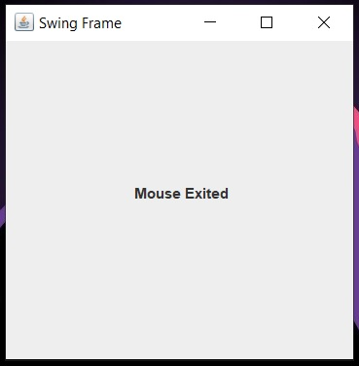 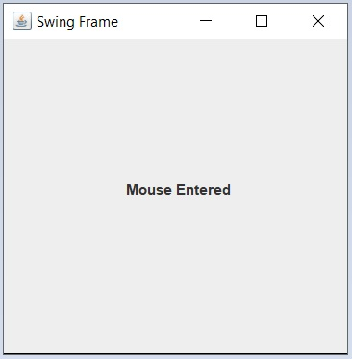

13b –

/** Main.java **/

import java.awt.*;

import java.awt.event.*;

import javax.swing.*;

public class Main {

JLabel l;

Main() {

JFrame f = new JFrame("Swing Pink");

l = new JLabel("This is some text", SwingConstants.CENTER);

l.setBounds(15, 15, 260, 30);

f.add(l);

f.getContentPane().setBackground(Color.PINK);

f.setSize(300, 100);

f.setLayout(null);

f.setVisible(true);

f.setDefaultCloseOperation(JFrame.EXIT_ON_CLOSE);

}

public static void main(String[] args) {

SwingUtilities.invokeLater(new Runnable() {

public void run() {

new Main();

}

});

}

}

Output –

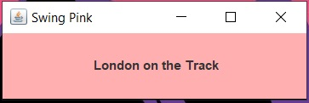

13c –

import java.awt.*;

import java.awt.event.*;

import javax.swing.*;

public class Main {

JButton btnRed, btnBlue;

Main() {

JFrame f = new JFrame("Swing Buttons");

btnRed = new JButton("Red");

btnRed.setBounds(16, 20, 250, 30);

btnRed.addActionListener(new ActionListener() {

@Override

public void actionPerformed(ActionEvent e) {

f.getContentPane().setBackground(Color.RED);

}

});

f.add(btnRed);

btnBlue = new JButton("Blue");

btnBlue.setBounds(16, 65, 250, 30);

btnBlue.addActionListener(new ActionListener() {

@Override

public void actionPerformed(ActionEvent e) {

f.getContentPane().setBackground(Color.BLUE);

}

});

f.add(btnBlue);

f.setSize(300, 160);

f.setLayout(null);

f.setVisible(true);

f.setDefaultCloseOperation(JFrame.EXIT_ON_CLOSE);

}

public static void main(String[] args) {

SwingUtilities.invokeLater(new Runnable() {

public void run() {

new Main();

}

});

}

}

Output –

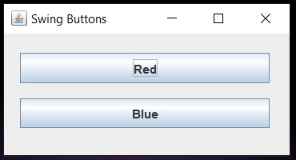 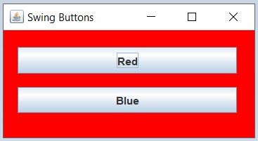

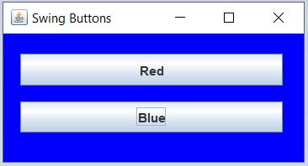

13d –

import java.awt.*;

import java.awt.event.*;

import javax.swing.*;

class KbdAdapter extends KeyAdapter {

JLabel l;

KbdAdapter(JLabel l) {

this.l = l;

}

@Override

public void keyTyped(KeyEvent e) {

l.setText("Typed character is: " + e.getKeyChar());

}

@Override

public void keyPressed(KeyEvent e) {

System.out.println("Pressed character is: " + e.getKeyChar());

}

@Override

public void keyReleased(KeyEvent e) {

System.out.println("Released character is: " + e.getKeyChar());

}

}

public class Main {

JLabel l;

Main() {

JFrame f = new JFrame("AWT Keyboard");

l = new JLabel("", SwingConstants.CENTER);

l.setBounds(15, 20, 250, 30);

f.addKeyListener(new KbdAdapter(l));

f.add(l);

f.setSize(300, 110);

f.setLayout(null);

f.setVisible(true);

f.setDefaultCloseOperation(JFrame.EXIT_ON_CLOSE);

}

public static void main(String[] args) {

SwingUtilities.invokeLater(new Runnable() {

public void run() {

new Main();

}

});

}

}

Output –

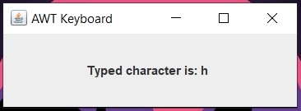 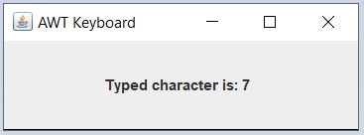

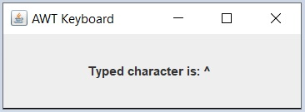

13e –

/** Main.java **/

import java.awt.*;

import java.awt.event.*;

import javax.swing.*;

public class Main implements ActionListener {

JButton btnInfo, btnCGPA;

Main() {

JFrame f = new JFrame("Student Details");

btnInfo = new JButton("A");

btnInfo.setBounds(18, 100, 450, 100);

btnInfo.addActionListener(this);

f.add(btnInfo);

btnCGPA = new JButton("B");

btnCGPA.setBounds(18, 270, 450, 100);

btnCGPA.addActionListener(this);

f.add(btnCGPA);

f.setSize(500, 500);

f.setLayout(null);

f.setVisible(true);

f.setLocationRelativeTo(null);

f.setDefaultCloseOperation(JFrame.EXIT_ON_CLOSE);

}

public static void main(String[] args) {

SwingUtilities.invokeLater(new Runnable() {

public void run() {

new Main();

}

});

}

@Override

public void actionPerformed(ActionEvent e) {

if (e.getSource() == btnInfo) {

new Information(

"SUDIPTO GHOSH",

"BSc (Hons) Computer Science",

"19/78003",

"ARSD College"

);

} else if (e.getSource() == btnCGPA) {

new CGPA("9.73");

}

}

}

/** Information.java **/

import java.awt.*;

import java.awt.event.*;

import javax.swing.*;

class Information {

JButton btnClose;

JPanel panelForm;

JLabel labelName, labelCourse, labelRollNo, labelCollege;

JTextField fieldName, fieldCourse, fieldRollNo, fieldCollege;

Information(String name, String course, String rollNo, String college) {

JFrame f = new JFrame("Personal Information");

labelName = new JLabel("Name:");

labelName.setBounds(30, 30, 90, 23);

labelCourse = new JLabel("Course:");

labelCourse.setBounds(30, 60, 100, 23);

labelRollNo = new JLabel("Roll No.:");

labelRollNo.setBounds(30, 90, 80, 23);

labelCollege = new JLabel("College:");

labelCollege.setBounds(30, 120, 90, 23);

fieldName = new JTextField(name);

fieldName.setBounds(120, 30, 210, 23);

fieldName.setEditable(false);

fieldCourse = new JTextField(course);

fieldCourse.setBounds(120, 60, 210, 23);

fieldCourse.setEditable(false);

fieldRollNo = new JTextField(rollNo);

fieldRollNo.setBounds(120, 90, 210, 23);

fieldRollNo.setEditable(false);

fieldCollege = new JTextField(college);

fieldCollege.setBounds(120, 120, 210, 23);

fieldCollege.setEditable(false);

btnClose = new JButton("Close");

btnClose.setBounds(110, 160, 140, 30);

btnClose.addActionListener(new ActionListener() {

@Override

public void actionPerformed(ActionEvent e) {

f.dispose();

}

});

panelForm = new JPanel();

panelForm.setLayout(null);

panelForm.add(labelName);

panelForm.add(fieldName);

panelForm.add(labelCourse);

panelForm.add(fieldCourse);

panelForm.add(labelRollNo);

panelForm.add(fieldRollNo);

panelForm.add(labelCollege);

panelForm.add(fieldCollege);

panelForm.add(btnClose);

f.add(panelForm);

f.setSize(380, 250);

f.setVisible(true);

f.setLayout(null);

f.setLocationRelativeTo(null);

f.setDefaultCloseOperation(JFrame.DISPOSE_ON_CLOSE);

}

}

/** CGPA.java **/

import java.awt.*;

import java.awt.event.*;

import javax.swing.*;

class CGPA {

JLabel l;

JButton btnClose;

CGPA(String cgpa) {

JFrame f = new JFrame("Previous Year CGPA");

l = new JLabel("Your CGPA was: " + cgpa, SwingConstants.CENTER);

l.setBounds(20, 20, 250, 30);

btnClose = new JButton("Close");

btnClose.setBounds(90, 60, 100, 30);

btnClose.addActionListener(new ActionListener() {

@Override

public void actionPerformed(ActionEvent e) {

f.dispose();

}

});

f.add(l);

f.add(btnClose);

f.setSize(310, 150);

f.setLayout(null);

f.setVisible(true);

f.setLocationRelativeTo(null);

f.setDefaultCloseOperation(JFrame.DISPOSE_ON_CLOSE);

}

}

Output –

